**PoC[1] Computing – Rapid access to Clinical Information**

Sam Yan

Student ID: 886958

E-mail: [yanjia@kean.edu](mailto:yanjia@kean.edu)

eHealth department of University of Melbourne, Australia

INTRODUCTION

Data is required “at the speed of life” in hospital. The proposed structure aims at solving rapid data access, which considers rapid authentication, rapid data network infrastructure and seamless virtual system experiences.

1. CHOSEN SOLUTION:
   1. SOLUTION OVERVIEW:

* Infrastructures for rapid authentication

The proposed authentication solution includes everyday first-time authentication, tap or facial recognition authentication when needed, and detection of not using when leaving the devices. For the first-time authentication, the Universal Second Factor (U2F) authentication is required. For “who I am”, facial recognition and smart card authentications are needed, while for “what I know”, password is needed. (Assumption 1) The authentication request will be checked with VBoxAuth to validate the identity of the user. Clinicians can simply just tap and remove the smart card used to open the door of their offices and wards to the NFC card reader embedded directly on each desktop machine, to start their work. It is only when every 6 hours later or abnormal login is detected, the system requires user to enter the password and tap-and-remove the smart card. Other times, depending on the place of the clinician, the authentication strategies will be slightly different, as shown in figure-1.

Clinicians only need to input the username and password to link to the wireless network on their first log-in when linking from wireless or mobile devices such as tablets, computers-on-wheels and their personal smart phones. After that, facial recognition system “Alibaba smile-to-pay”, which can be embedded into smart phones or tablets as a software, will be used as the authentication tool for user authentication. [2][9][13]

To determine whether the user is disconnected, an infrared sensor installed to each desktops keeps checking the distances to the people using the computer. (Assumption 2). 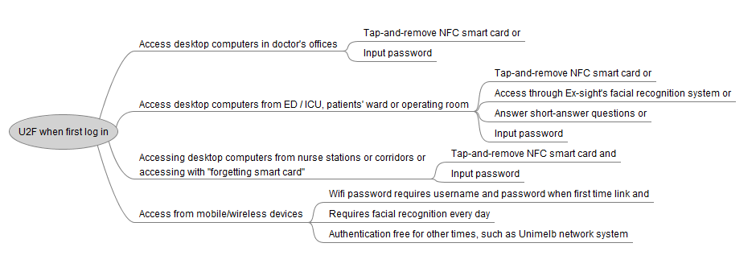

*Figure 1: Proposed solutions for authentication strategies based on different scenarios, draw by myself using software MindV.*

Also, in cases that clinicians forgot to bring the card (Assumption 2), it will be invalidated by the card reader and the computer uses the short message services (SMS) to send a message to both of the doctor and IT department of the hospital to remind them of smart card being left. The card will be validated again after doctor putting the password into the system with his or her smart card being tapped-and-removed on the reader.

* Solutions to network topologies and backup strategies

Two data centers in the hospital uses two different 10Gbps optical fiber to link to Oracle remote server through Wide Area Network (WAN). For two data centers, they all use Hewlett-Packard server machines, one for daily use while another is used for backup and load balancing. The two data centers and the remote server should have proper backup strategies in between one and another. (Assumption 3) Two data centers link to each other by 10Gbps optical fiber forming a ring topology also.

To build the backbone structures of the campus area network (CAN) of the hospital, Cisco Switches on each floor are linked to every desktop computers and TP-LINK routers on each floor link to two hospital data centers with 10Gbps optical fibers, the TP-LINK router each works as an forwarding NAT node.

On each floor, several other private subnet TP-LINK routers are linked to the forwarding NAT node. The subnet router each works as a relay node used to amply signals. They are shared by the rooms by certain rules depending on the department’s requirement of rapid data. (Assumption 4)

Desktop computers using Oracle VirtualBox virtual systems are linked directly to the switches on each floor through 1Gbps twisted copper wired cables, and remains wireless access points as well to prevent the case that cables breaks down. (Assumption 5) The switches links to the scanners or printing machines also, which work as subnet devices on each floor to help clinicians scan or print data. Other mobile devices such as smart phones and tablets links to the NAT routers through amplification relay nodes shared by the rooms. The overall infrastructure of rapid access network looks as below:

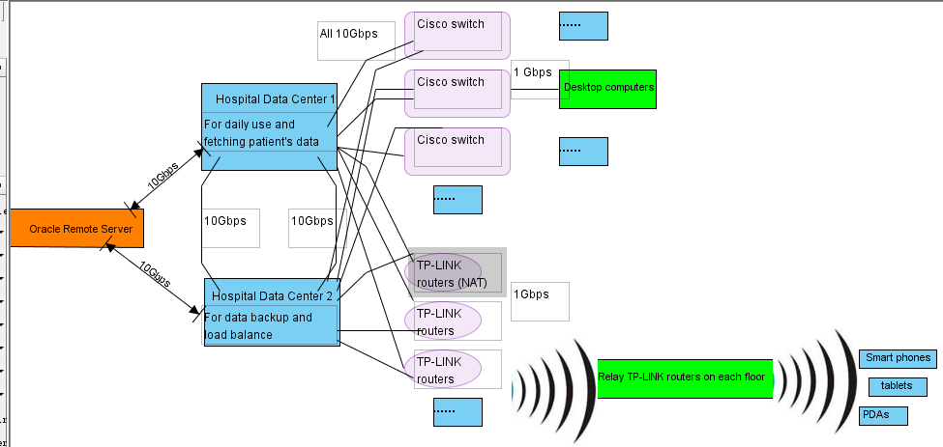

*Figure 2: Proposed solutions for rapid access network infrastructure, draw by myself using software Visual Paradigm.*

* Virtual desktops and user experiences

The virtual systems installed on each computer are set to automatically “start-at-boot”. [Oracle enterprise set] After clinicians logged on or connected to the current session, all the applications are popped up, from exactly where last time the clinician disconnected his or her session. The data of patients’ EHRs, the status of changes on each desktop are loaded and saved to the hospital data center, at the speed quicker than 500Mbps. The switch between different applications and different patient data are achieved by “Enterprise SSO” technique and the login automation tools are implemented by IT, to ensure the seamless transfer between data of different patients and different medical applications.

Each of the desktop is equipped with an authentication credential license from Oracle cloud service, namely, the number of licenses for Virtual Desktop service equals number of desktop computers, regardless of amount of users or the identity of users currently using the desktop virtual service.

* 1. WHY CHOSEN:

The general solution of the infrastructure should consider about authentications, quick access of data and consistent user experiences, easy to integrate and implement, network topologies and backup strategies and proper budgets.

The start-of-the day authentication ensures the confidentiality of the information. Two methods are used for the “who I am” factor of U2F under the consideration of minimizing the possibility of identification being manipulated, compared to using only each element of U2F. [3]. Short answer questions (similar to finding Apple ID) are allowed to life-critical departments to further ensure accessibility especially in emergent cases, while the solution for computers in corridors or nurse stations requires higher level of information confidentiality.

As for the network infrastructure part, two data centers and the Oracle remote server was proposed and the backup and transmission rules was set to ensure data integrity and to minimize amount of information to be exchanged during rush hours in order to lower down the network balance. A thin-client structure is proposed and most data transmission and storing loads are put to the data center, ensuring easy-to-maintain, energy-saving and lower costs on end-user computers, and at the same time offering end-users consistent data and experiences. [8] The service provider Oracle cloud is Java-based, which ensures portability across different platforms. [10] Virtualbox desktop virtualization system is also provided by Oracle, ensuring the integration with Oracle cloud and makes the whole structure easy to implement, integrate and scale. As for comparison, Citrix offer a good set of save and managed infrastructure, but it seems Oracle structures tend to win on scalability, which is really good for a changing and high-demanding environment such as a hospital. Other platforms, such as Microsoft Azure, might also having similar problems. As for desktop virtualization, Vmware could be a really good choice, but Oracle Virtualbox is itself a free platform, making it cost less, easier-to-implement and scalable. [10]

In a scenario of a hospital, the access to virtual system services for clinicians can happen at different places by different clinicians under a changing scale, so the authentication credentials are given to machines, rather than a single clinician.

1. Clinician benefits

This solution has a significant impact on the clinician’s workflow. First of all, wasting time on repeatedly logging-on and off is solved, the password is required only each 6 hours in normal cases. Secondly, by using the virtualization desktop equipped with login automation tools, it takes less time for clinicians to medicate different patients, using different medical-related applications and moving to computers located in different places. Thirdly, the solution already considered different environments of the hospital. For example, the authentication processes of the ED, ICU and operating rooms (allowing short-answer questions besides the normal U2F) are simpler than those in offices, wards, nurses’ stations and corridors, ensuring quicker access in more critical places and information confidentiality in public spaces. As for the network structure, loads created by mobile devices (possibly from patients and clinicians not working on the fast desktop virtualization systems) are handled by wireless networks, further ensuring the rapid access of data for those working-purpose computers located in critical places. It is worth noticing that a wireless network having 1Gbps for mobile devices can still ensuring the basic needs by those devices, ensuring some basic needs for the mobility of the clinicians. Use of license for each desktop computer can always ensure the availability under clinicians’ needs, although it might costs more compared to limit the number of limiting the number of licenses being active.

(Word count: 1298, by excluding the INTRODUCTION, captions of the figures, and notations)

ASSUMPTIONS

1. For every day when a clinician arrive at the gate of the hospital, the person needs to stand in front of the integrated touch-screen computer at the gate of the hospital to take a photo and at the same time tap and remove his or her smart card, and enter the password of his or her system, the photo is sent to the Oracle “Multimedia Analytics system” for facial recognition purposes. [5]
2. Clinicians are detected as “left the machine” by standing more than 1.5 meters from machine for more than 30 seconds. They are assumed to forget their smart card if the assumed of leaving satisfies and the smart card is still put on the machine.
3. Two separate rooms for hospital data center in two different buildings. And the optical fiber linking from the data centers to the remote server should be go in different directions, to avoid potential damage to the data. The two data centers and the Oracle remote server back up the changed parts of clinical data at 18:00 every day automatically, or when after discovery from disconnect between any of the data center to remote server happened (due to a sudden break down between the three 10Gbps lines linking data centers and the service provider).
4. As for clinicians’ offices and wards, every three rooms share a router, each allowing 15 devices to connect to it, which connects to the NAT router of each floor and then connects to the main server following a start topology. For emergency department and ICU, due to the potential access to wireless network is higher, 2 rooms share a router which connects to the NAT router located on each floor.
5. Each room of office, ED, ward, ICU, operating room has an integrated computer containing card reader and infrared detector, every 20 desktop computers are linked to one switch having 10Gbps link. This can hopefully ensures the access by 500 Mbps at rush hours and 1Gbps at normal hours. The desktop computers should be able to have software embedded which can automatically detects the best way to connect to internet. Thus in case that the optical fiber line broke, it is able to connect to the subnet router on each floor automatically.

BIBLIOGRAPHY

1. Abdalla, I., Davis, D., Segal, B., & Trueman, C. W. (2004). Wireless-local-area-network deployment issues in hospitals: Capacity, coverage electromagnetic compatibility. In *2004 10th International Symposium on Antenna Technology and Applied Electromagnetics and URSI Conference* (pp. 1–6). <https://doi.org/10.1109/ANTEM.2004.7860570>

Reason to list as top 3: This paper informs us about security issues when building WAN network linking to hospitals, which worth our attention when considering about the issue.

1. Lu, J., Wang, G., & Zhou, J. (2017). Simultaneous Feature and Dictionary Learning for Image Set Based Face Recognition. *IEEE Transactions on Image Processing*, *26*(8), 4042–4054. <https://doi.org/10.1109/TIP.2017.2713940>

Reason to list as top 3: This paper introduced the most recent research progress of the IT company Alibaba’s facial recognition technology, using machine learning and improved the accuracy, which is worth studying.

1. Reimair, F., Kollmann, C., & Marsalek, A. (2016). Emulating U2F authenticator devices. In *2016 IEEE Conference on Communications and Network Security (CNS)* (pp. 543–551). <https://doi.org/10.1109/CNS.2016.7860546>

Reason to list as top 3: This paper introduced the reason why U2F might be manipulated, leading to the enhanced “who am I” version proposed by this paper.

1. 6.3. Creating a New Virtual Machine in VirtualBox. (n.d.). Retrieved March 24, 2018, from <https://docs.oracle.com/cd/E26217_01/E26796/html/qs-create-vm.html>
2. Big Data Spatial and Graph User’s Guide and Reference. (n.d.). Retrieved March 22, 2018, from <https://docs.oracle.com/cd/E65728_01/doc.43/e67958/GUID-4B15F058-BCE7-4A3C-A6B8-163DB2D4368B.htm#BDSPA-GUID-4B15F058-BCE7-4A3C-A6B8-163DB2D4368B>
3. Chapter 7. Remote virtual machines. (n.d.). Retrieved March 22, 2018, from <https://www.virtualbox.org/manual/ch07.html#vbox-auth>
4. Downloads – Oracle VM VirtualBox. (n.d.). Retrieved March 23, 2018, from <https://www.virtualbox.org/wiki/Downloads>
5. Hayes, J. (2009). Thin clients’ fat challenge [IT Desktop Computing]. *Engineering Technology*, *4*(21), 52–53. <https://doi.org/10.1049/et.2009.2112>
6. Jack Ma Demonstrates Face-recognition Payment Tech | Alizila.com. (n.d.). Retrieved March 24, 2018, from <http://www.alizila.com/video/jack-ma-demonstrates-face-recognition-payment-tech/>
7. Oracle VM VirtualBox®. (n.d.). Retrieved March 24, 2018, from <https://www.virtualbox.org/manual/>
8. WWMK160606P00068. (n.d.). Retrieved March 22, 2018, from <https://go.oracle.com/LP=33481?elqCampaignId=50003&src1=ad:pas:go:dg:paas1&src2=wwmk160606p00080c0001&SC=sckw=WWMK160606P00080C0001&mkwid=s|pcrid|201127082520|pkw|oracle%20cloud|pmt|e|pdv|c|sckw=srch:oracle%20cloud>
9. XenApp and XenDesktop Service for App and Desktop Virtualization. (n.d.). Retrieved March 22, 2018, from <https://www.citrix.com/products/citrix-cloud/xenapp-xendesktop-service.html>
10. Zeng, J., Liu, S., Li, X., Mahdi, D. A., Wu, F., & Wang, G. (2018). Deep Context-Sensitive Facial Landmark Detection With Tree-Structured Modeling. *IEEE Transactions on Image Processing*, *27*(5), 2096–2107. <https://doi.org/10.1109/TIP.2017.2784571>

1. “PoC = Point of Care - Computing at the point where clinicians provide care to patients and assist each other“, according to Mr.Frank Smolenaers’ assignment specification.